Simple Regression Exercises
Chester Ismay, Albert Kim, Jenny Smetzer, Jenny Brian, Kim Roth, and Carolyn Cuff
8/8/2023
ModernDive is under a Creative Commons Attribution - NonCommercial - ShareAlike 4.0 license so it is able to be modified with attribution as above. These are exercises based partially on the Learning Checks in ModernDive.
This assignment is based on one by Albert Kim and Jenny Smetzer designed to accompany the book. The car correlation activity was from a workshop with Robin Lock.

Setup

Libraries
library(tidyverse) #ggplot, etc
## ── Attaching core tidyverse packages ──────────────────────── tidyverse 2.0.0 ──
## ✔ dplyr 1.1.4 ✔ readr 2.1.5
## ✔ forcats 1.0.0 ✔ stringr 1.5.1
## ✔ ggplot2 3.5.1 ✔ tibble 3.2.1
## ✔ lubridate 1.9.3 ✔ tidyr 1.3.1
## ✔ purrr 1.0.2
## ── Conflicts ────────────────────────────────────────── tidyverse_conflicts() ──
## ✖ dplyr::filter() masks stats::filter()
## ✖ dplyr::lag() masks stats::lag()
## ℹ Use the conflicted package (<http://conflicted.r-lib.org/>) to force all conflicts to become errors
library(moderndive) #the pretty regression tools
library(fueleconomy)
vehicles=fueleconomy::vehicles #the data set

R chunk settings. Don’t worry about this code. It sets up the size of the graphs

Background
For this problem set you will first run through an example of a simple linear regression, answering a few questions on the way. Then you will work through a regression analysis independently. Knit this file…and you can read through all the instructions. You can do your work in this .Rmd file….simply insert your answers below each Question, knit your final copy, and turn in the .docx file.
We will look at data from the fueleconomy package about cars. The details about the variables can be found here. https://cran.r-project.org/web/packages/fueleconomy/fueleconomy.pdf Since it is a large data set, we’ll use the most recent model year in the data set which is 2015.
vehicles2015=vehicles%>%
filter(year==2015)
vehicles2015
## # A tibble: 205 × 12
## id make model year class trans drive cyl displ fuel hwy cty
## <dbl> <chr> <chr> <dbl> <chr> <chr> <chr> <dbl> <dbl> <chr> <dbl> <dbl>
## 1 34839 Acura RDX 2WD 2015 Small… Auto… Fron… 6 3.5 Prem… 28 20
## 2 34843 Acura RDX 4WD 2015 Small… Auto… All-… 6 3.5 Prem… 27 19
## 3 34771 Audi A3 2015 Subco… Auto… Fron… 4 2 Prem… 33 23
## 4 34710 Audi A3 quattro 2015 Subco… Auto… All-… 4 1.8 Prem… 33 24
## 5 34925 Audi A8 2015 Midsi… Auto… All-… 8 4 Prem… 30 18
## 6 34926 Audi A8 2015 Midsi… Auto… All-… 6 3 Prem… 29 19
## 7 34928 Audi A8 L 2015 Large… Auto… All-… 8 4 Prem… 29 18
## 8 34929 Audi A8 L 2015 Large… Auto… All-… 12 6.3 Prem… 22 14
## 9 34930 Audi A8 L 2015 Large… Auto… All-… 6 3 Dies… 36 24
## 10 34931 Audi A8 L 2015 Large… Auto… All-… 6 3 Prem… 29 19
## # ℹ 195 more rows
This activity will focus on the relationships among several of these variables including:
cty = EPA's estimated miles per gallon for city driving
hwy = EPA's estimated miles per gallon for highway driving
cyl = number of cylinders in engine, larger engines have more cylinders
displ = displacement of engine in liters, larger engines have more displacement

Initial guesses (BEFORE looking at the data)
Consider the relationship you would expect to see between each the following pairs of variables for the car data.
- cty vs. hwy
- cty vs. cyl
- hwy vs. displ
- cty vs. displ
- cyl vs. displ

Question 1.
For each pair of variables indicate the strength (strong, moderate, weak, no association) and the direction (positive, negative, no association) of the relationship between the variables. These should be guesses and it is okay if they are wrong. Feel free to write a sentence why if you have reason.
- cty vs. hwy
I would expect there to be a strong positive association in this case since cty and hwy both seem to refer to a car’s fuel efficiency if I understand correctly.
- cty vs. cyl
My guess is that there would be a moderate negative association in this case. A greater value of cyl implies a larger engine, which in turn implies a larger car. I’m not an automobile expert so I could be mistaken but I think larger cars are less fuel efficient?
- hwy vs. displ
My guess is that there would be a moderate negative association, for exactly the same reasons I stated in (b).
- cyl vs. displ
I would expect a positive association since larger values of cyl and displ are supposed to be affiliated with larger engine sizes, I’m just not sure how strong the relationship would be. I’ll go with moderate.

Question 2
Make scatterplots for each pair of variables then update your guesses for the strength (strong, moderate, weak, no association) and the direction (positive, negative, no association) of the relationship between the variables. Give a sentence to explain your new guess. The first one is done for you except for the matching your guess part.
- cty vs. hwy
ggplot(data=vehicles2015, mapping=aes(x=hwy, y=cty))+
geom_point()+
labs(y="City Miles Per Gallon", x="Highway Miles Per Gallon",
title=" City versus Highway mileage for 2015 model vehicles")
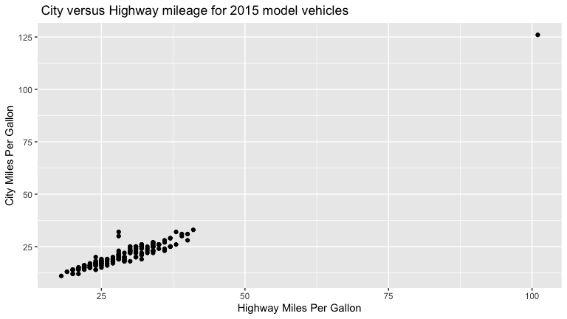
Generally there is a strong positive association. It is very close to a line. There is this one outlier and I am going to remove it before proceeding so you do not have an outlier on all your plots. Removing outliers is a tricky (statistical) business, you do not want to remove an outlier just because it is an outlier. Here it makes some sense, which we’ll see below.
filter(vehicles2015, cty>100|hwy>100)
## # A tibble: 1 × 12
## id make model year class trans drive cyl displ fuel hwy cty
## <dbl> <chr> <chr> <dbl> <chr> <chr> <chr> <dbl> <dbl> <chr> <dbl> <dbl>
## 1 34918 Nissan Leaf 2015 Midsize Ca… Auto… Fron… NA NA Elec… 101 126
The outlier is the Nissan Leaf, which is an electric car, so unsurprising and isn’t comparable to gasoline fueled cars. We SHOULD remove this outlier since it is not a gasoline powered car like the rest of the cases in this data set. Removing an outlier JUST because it is not like the other data points is NOT recommended.
vehicles2015=filter(vehicles2015, cty<100|hwy<100)
Now the graph again
ggplot(data=vehicles2015, mapping=aes(y=cty, x=hwy))+
geom_point()+
labs(y="City Miles Per Gallon", x="Highway Miles Per Gallon",
title=" City versus Highway mileage for 2015 model vehicles")
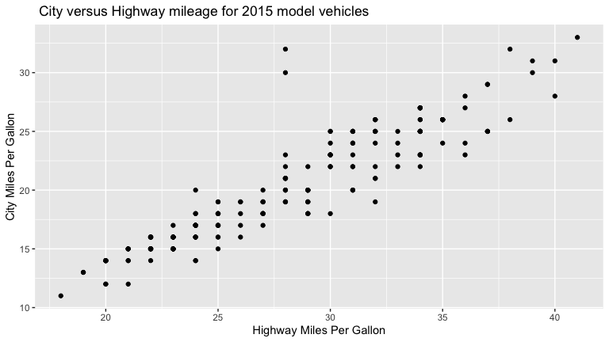
Note the strength of the association appears to be less in this graph. However, it still a fairly strong positive linear association. There are the two points ones away from the main line at about 25 mpg highway. It is expected as city miles per gallon and highway miles per gallon are two measures of fuel efficiency for a car and they should be positively related.
Does it match your guess? Graph and describe each relationship below. Then comment on your previous guess and the relationship seen in the graph.
I would say the above graph does match my guess for (a). Visually the points are arranged in a pretty linear manner with higher values of cty tending to pair with higher values of hwy.
- cty vs. cyl
ggplot(data=vehicles2015, mapping=aes(y=cty, x=cyl))+
geom_point(alpha=0.20)
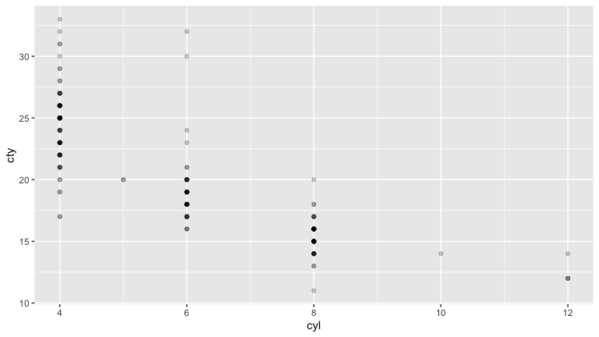
Going by the graph above I would say that my initial guess for (b) was correct and there is a moderate negative association. I say moderate rather than strong because the trend doesn’t exactly look linear; it looks like there may be disproportionately more points in the leftmost cluster and disproportionately few points in the rightmost cluster but it’s a little hard to say for certain.
- hwy vs. displ
ggplot(data=vehicles2015, mapping=aes(y=hwy, x=displ))+
geom_point(alpha=0.5)
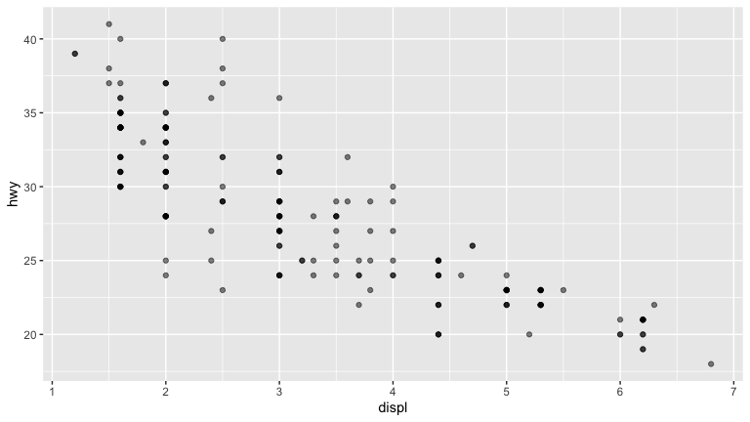
While I’m tempted to say that the association here might be stronger than the one in (b), I still think my guess of moderate negative association works.
- cyl vs. displ
ggplot(data=vehicles2015, mapping=aes(y=cyl, x=displ))+
geom_point(alpha=0.2)
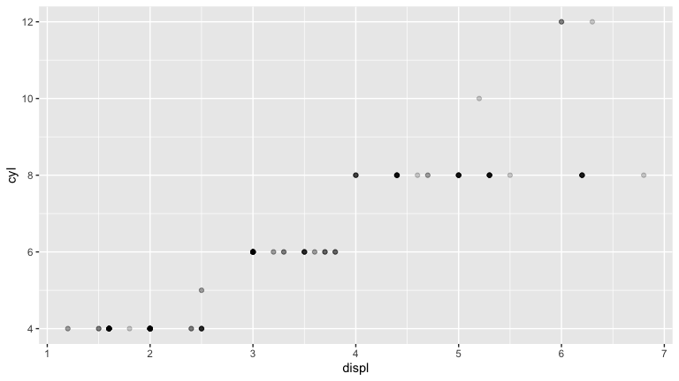
I’d still go with a moderate positive association. I guess some of the clusters are a bit too spread out for me to be comfortable calling it a strong positive association.

Question 3
The correlation coefficient, denoted by r, is a measure of the strength of the linear association between two quantitative variables. Use R to compute the correlation for each of the pairs of variables. I’ll do the first one. Does this match your answers to questions 1 and 2? Why or why not.
- cty vs. hwy
vehicles2015 %>%
get_correlation(formula=hwy~cty) #moderndive code
## # A tibble: 1 × 1
## cor
## <dbl>
## 1 0.920
0.92 is a strong positive correlation, so that mostly matches my guesses for 1 and 2. How about yours?
It matches with both my guesses for 1 and 2. I would probably consider 0.92 to be a strong positive correlation.
- cty vs. cyl
vehicles2015 %>%
get_correlation(formula=cyl~cty)
## # A tibble: 1 × 1
## cor
## <dbl>
## 1 -0.830
The association suggested by this value is probably stronger than I said it was in 1 and 2. A correlation with an absolute value above 0.8 can probably be considered fairly strong.
- hwy vs. displ
vehicles2015 %>%
get_correlation(formula=displ~hwy)
## # A tibble: 1 × 1
## cor
## <dbl>
## 1 -0.849
I was technically on the right track in saying that the association seemed stronger than the one in (b), but I think I still understated the strength of the association in 1 and 2 for the same reason I cited in (c) above.
- cyl vs. displ
vehicles2015 %>%
get_correlation(formula=cyl~displ)
## # A tibble: 1 × 1
## cor
## <dbl>
## 1 0.931
I want to say this is the one where I was off the most. I said it was a moderate positive association but it actually has the highest correlation out of the four pairings.

Linear Models
Here is a linear model of cty as predicted by hwy and its tables and graph.
ctyhwy=lm(cty~hwy, data=vehicles2015) #model
get_regression_table(ctyhwy) #regression table
## # A tibble: 2 × 7
## term estimate std_error statistic p_value lower_ci upper_ci
## <chr> <dbl> <dbl> <dbl> <dbl> <dbl> <dbl>
## 1 intercept -3.10 0.713 -4.34 0 -4.50 -1.69
## 2 hwy 0.828 0.025 33.4 0 0.779 0.877
get_regression_points(ctyhwy) #table of predicted points and residuals.
## # A tibble: 204 × 5
## ID cty hwy cty_hat residual
## <int> <dbl> <dbl> <dbl> <dbl>
## 1 1 20 28 20.1 -0.087
## 2 2 19 27 19.3 -0.259
## 3 3 23 33 24.2 -1.23
## 4 4 24 33 24.2 -0.227
## 5 5 18 30 21.7 -3.74
## 6 6 19 29 20.9 -1.92
## 7 7 18 29 20.9 -2.92
## 8 8 14 22 15.1 -1.12
## 9 9 24 36 26.7 -2.71
## 10 10 19 29 20.9 -1.92
## # ℹ 194 more rows
Graph the relationship
ggplot(data=vehicles2015, mapping=aes(y=cty, x=hwy))+
geom_point()+
labs(y="City Miles Per Gallon", x="Highway Miles Per Gallon",
title=" City versus Highway mileage for 2015 model vehicles")+
geom_smooth(method="lm",se=0)
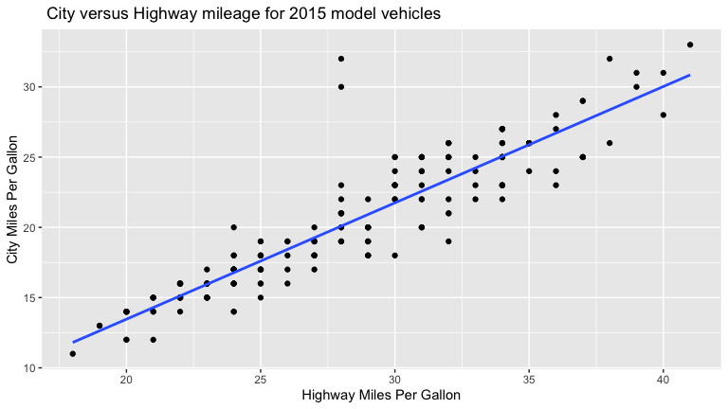

Question 4
Make a linear model for hwy as predicted by displ and its table and graph.
ctyhwy=lm(hwy~displ, data=vehicles2015)
get_regression_table(ctyhwy)
## # A tibble: 2 × 7
## term estimate std_error statistic p_value lower_ci upper_ci
## <chr> <dbl> <dbl> <dbl> <dbl> <dbl> <dbl>
## 1 intercept 38.0 0.472 80.6 0 37.1 39.0
## 2 displ -3.05 0.133 -22.8 0 -3.31 -2.78
get_regression_points(ctyhwy)
## # A tibble: 204 × 5
## ID hwy displ hwy_hat residual
## <int> <dbl> <dbl> <dbl> <dbl>
## 1 1 28 3.5 27.4 0.628
## 2 2 27 3.5 27.4 -0.372
## 3 3 33 2 31.9 1.06
## 4 4 33 1.8 32.6 0.45
## 5 5 30 4 25.8 4.15
## 6 6 29 3 28.9 0.105
## 7 7 29 4 25.8 3.15
## 8 8 22 6.3 18.8 3.16
## 9 9 36 3 28.9 7.10
## 10 10 29 3 28.9 0.105
## # ℹ 194 more rows
ggplot(data=vehicles2015, mapping=aes(y=hwy, x=displ))+
geom_point()+
geom_smooth(method="lm",se=0)
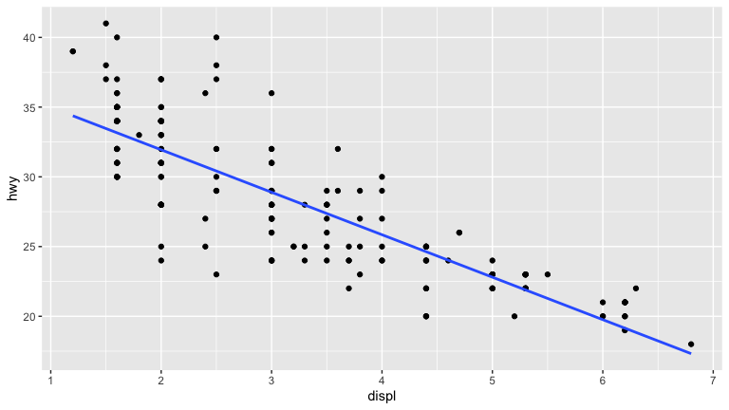
- How is the fit? Does it look like a linear model?
The fit seems worse on the left half of the graph compared to the right but it still looks like a linear model.
- Give the equation of the regression line. Use predicted before the name of your predicted variable.
predicted hwy=(-3.406)*displ+38.032
- Interpret the slope of your model
The slope of -3.406 tells us that an increase of displ by 1 liter is associated with a decrease in hwy of -3.406 miles per gallon.
- Interpret the intercept of your model. Is this a practical interpretation here? Why or why not?
The mathematical intepretation of the intercept 38.032 is that it is the predicted value of hwy when displ=0. I’m guessing that a displ of 0 does not actually make practical sense but I don’t really know anything about how engine displacement works.
- Predict the hwy for a displ of 2.5 liters. Show your work.
(-3.406)*2.5+38.032
## [1] 29.517
The predicted hwy is 29.517.
- Find the residual for the displ of 3 liters. Make sure you specify which car you are using for the actual data and show what the calculation would be.
vehicles2015%>%
filter(displ==3)%>%
select(model, hwy)
## # A tibble: 27 × 2
## model hwy
## <chr> <dbl>
## 1 A8 29
## 2 A8 L 36
## 3 A8 L 29
## 4 435i Gran Coupe 32
## 5 640i Convertible 31
## 6 640i Coupe 32
## 7 640i Gran Coupe 31
## 8 640i xDrive Convertible 29
## 9 640i xDrive Coupe 29
## 10 640i xDrive Gran Coupe 29
## # ℹ 17 more rows
(-3.406)*3+38.032-29
## [1] -1.186
I chose model A8 for the calculation. The residual is -1.186.

Categorical predictors
Here is a linear model of hwy as predicted by fuel and its tables and its associated graph
ggplot(data=vehicles2015, mapping=aes(y=hwy, x=fuel))+
geom_point()+
labs(title="Highway Miles Per Gallon by Fuel Type",
x="Fuel Type Reccomended/Used", y="Highway MPG")
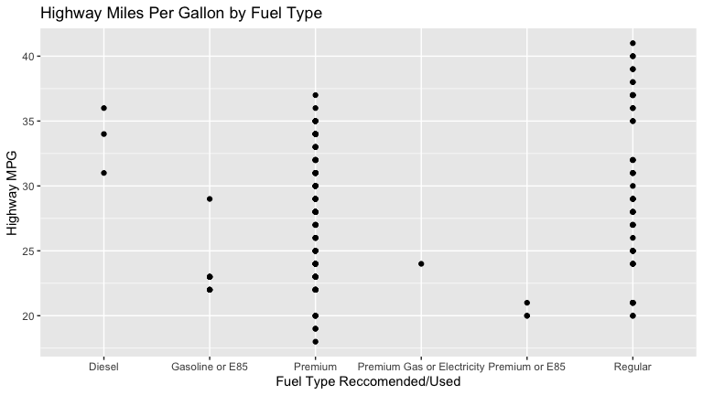
hwyfuel=lm(hwy~fuel, data=vehicles2015)
get_regression_table(hwyfuel)
## # A tibble: 6 × 7
## term estimate std_error statistic p_value lower_ci upper_ci
## <chr> <dbl> <dbl> <dbl> <dbl> <dbl> <dbl>
## 1 intercept 33.7 2.88 11.7 0 28.0 39.3
## 2 fuel: Gasoline or E85 -10.7 3.20 -3.34 0.001 -17.0 -4.37
## 3 fuel: Premium -5.39 2.91 -1.85 0.066 -11.1 0.355
## 4 fuel: Premium Gas or E… -9.67 5.76 -1.68 0.095 -21.0 1.69
## 5 fuel: Premium or E85 -13.3 4.07 -3.27 0.001 -21.4 -5.30
## 6 fuel: Regular -4.07 2.96 -1.38 0.17 -9.90 1.76
get_regression_points(hwyfuel)
## # A tibble: 204 × 5
## ID hwy fuel hwy_hat residual
## <int> <dbl> <chr> <dbl> <dbl>
## 1 1 28 Premium 28.3 -0.276
## 2 2 27 Premium 28.3 -1.28
## 3 3 33 Premium 28.3 4.72
## 4 4 33 Premium 28.3 4.72
## 5 5 30 Premium 28.3 1.72
## 6 6 29 Premium 28.3 0.724
## 7 7 29 Premium 28.3 0.724
## 8 8 22 Premium 28.3 -6.28
## 9 9 36 Diesel 33.7 2.33
## 10 10 29 Premium 28.3 0.724
## # ℹ 194 more rows
Interestingly, all the indicator functions have a negative slope meaning they are below the overall average for diesel, the only variable which is not an indicator, which makes sense as diesel fuel is generally more efficient.
Note if we were doing this later in the semester, we may want to combine or remove the smaller groups.

Question 5
Make a linear model of cty as predicted by drive, its associated graph and its tables
ggplot(data=vehicles2015, mapping=aes(y=cty, x=drive))+
geom_point()
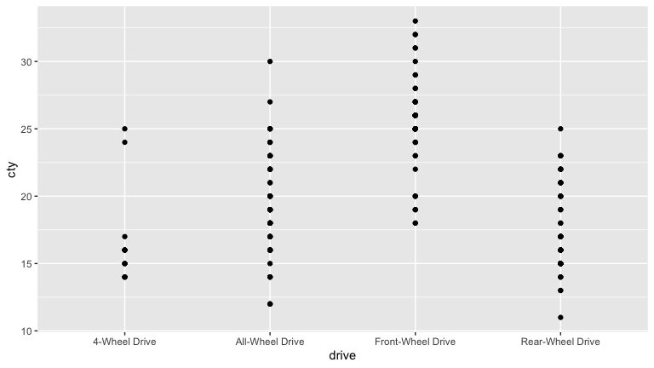
ctydrive=lm(cty~drive, data=vehicles2015)
get_regression_table(ctydrive)
## # A tibble: 4 × 7
## term estimate std_error statistic p_value lower_ci upper_ci
## <chr> <dbl> <dbl> <dbl> <dbl> <dbl> <dbl>
## 1 intercept 16.5 0.874 18.8 0 14.7 18.2
## 2 drive: All-Wheel Drive 2.79 0.967 2.88 0.004 0.881 4.69
## 3 drive: Front-Wheel Dri… 8.87 0.977 9.07 0 6.94 10.8
## 4 drive: Rear-Wheel Drive 1.00 0.974 1.03 0.305 -0.919 2.92
get_regression_points(ctydrive)
## # A tibble: 204 × 5
## ID cty drive cty_hat residual
## <int> <dbl> <chr> <dbl> <dbl>
## 1 1 20 Front-Wheel Drive 25.3 -5.33
## 2 2 19 All-Wheel Drive 19.3 -0.254
## 3 3 23 Front-Wheel Drive 25.3 -2.33
## 4 4 24 All-Wheel Drive 19.3 4.75
## 5 5 18 All-Wheel Drive 19.3 -1.25
## 6 6 19 All-Wheel Drive 19.3 -0.254
## 7 7 18 All-Wheel Drive 19.3 -1.25
## 8 8 14 All-Wheel Drive 19.3 -5.25
## 9 9 24 All-Wheel Drive 19.3 4.75
## 10 10 19 All-Wheel Drive 19.3 -0.254
## # ℹ 194 more rows
- Give the equation for your linear model. Write the indicator variables as 1_variableName rather than typesetting.
predicted cty=16.467+2.787(1_All-Wheel(drive))+8.867(1_Front-Wheel(drive))+1.001*(1_Rear-Wheel(drive)).
- What drive option is indicated by 0 on all the indicator functions.
4-Wheel Drive.
- Explain how the predicted cty for a Front-Wheel Drive car is calculated.
The indicator function for Front-Wheel Drive, 1_Front-Wheel, would have a value of 1 and the other indicator functions would have values of 0, so the equation above would simplify to: predicted cty=16.467+8.867.
- Explain what the slope of All-Wheel Drive tells us about All-Wheel Drive vehicles.
The slope of All-Wheel Drive, which is 2.787, tells us that the average value of cty for All-Wheel Drive is 2.787 miles per gallon higher than the average value of cty for 4-Wheel Drive, which is 16.467 miles per gallon.

